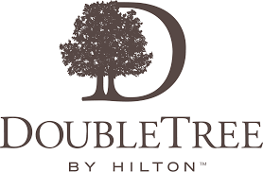

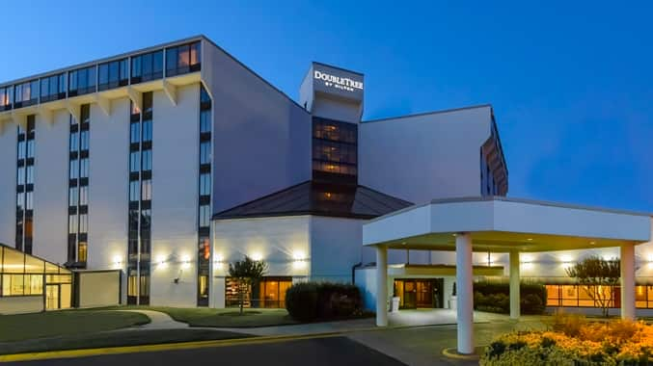
Feel welcome from the moment you arrive at DoubleTree by Hilton Hotel Richmond – Midlothian, with a freshly baked cookie at check-in. Our hotel is a short drive from downtown Richmond and is close to businesses, corporations, entertainment and shopping destinations including Chesterfield Town Center Mall, with over 200 specialty shops and restaurants and the charming village of Midlothian.
Our hotel is near sports venues such as River City Sports and Greater Richmond Aquatics (GRAP), leisure facilities including bowling and entertainment at Uptown Alley, and rock climbing at Peak Experiences. We offer a complimentary shuttle service within a five-mile radius of the hotel.
Our spacious guest rooms feature a microwave, refrigerator, comfortable Serta beds, an executive work area with ergonomic chairs and complimentary WiFi. Upgrade to a suite for a separate seating area and sofa bed.
Hold an event at this Richmond, VA hotel with 26,000 sq. ft. of flexible conference space, two ballrooms, a business center, the latest A/V equipment, professional event planners and catering services. Enjoy the pool and complimentary fitness room or for a reasonable fee, work out in the nearby gym facility, offering tennis, an outdoor water park, racquetball and a spa.
Enjoy lunch in Midlo Bistro Café and sip cocktails in the relaxed Atrium Lobby Lounge. Visions Dance Club provides live entertainment on weekends and DJ/theme nights during the week.
Room Rate - $94/night + taxes/fees
To make reservations, call 1-800-222-TREE (222-8733) and let the reservation representative know that you are booking with the VCA Group

